VITALWEAR

## A MINI-PROJECT REPORT

***Submitted by***

|  |  |
| --- | --- |
| **SIVANANTHAM D** | **210701250** |
| **GOPAL K** | **210701517** |

***in partial fulfillment of the award of the degree of***

# BACHELOR OF ENGINEERING

**IN**

**COMPUTER SCIENCE ENGINEERING**



# RAJALAKSHMI ENGINEERING COLLEGE, ANNA UNIVERSITY: CHENNAI 600 025

## MAY 2024

**BONAFIDE CERTIFICATE**

Certified that this project report titled “**VITALWEAR - A IOT BASED HEALTH MONITORING SYSTEM”** is the bonafide work of “SIVANANTHAM D (210701250) ,GOPAL K (210701517) who carried out the work under my supervision. Certified further that to the best of my knowledge the work reported herein does not form part of any other thesis or dissertation on the basis of which a degree or award was conferred on an earlier occasion on this or any other candidate.

## SIGNATURE

Mrs. Anitha Ashishdeep M.Tech.,

## SUPERVISOR

Assistant Professor

Department of Computer Science and Engineering

Rajalakshmi Engineering College

Chennai – 601 105

Submitted to Project Viva-Voce Examination held on

**Internal Examiner External Examiner**

## ABSTRACT

In order to provide immediate assistance and better health outcomes, the "VITALWEAR" project provides a state-of-the-art Internet of Things-based health monitoring system that is intended to continually track and manage numerous health metrics of an individual. To provide thorough health monitoring, this system incorporates a number of sensors, such as the blood oxygen (SpO2), heart rate, and temperature and humidity DHT11 sensors. The Blynk IoT platform is used to process and handle the data from various sensors, enabling smooth real-time monitoring and communication. To provide alerts and messages that are easy to understand, a specially designed Android application communicates with the Blynk platform. The system notifies the user right away when any sensor reading exceeds pre-established threshold levels or if the sensors are not worn correctly, allowing for rapid response and action. In addition to giving people the tools to actively manage their health, this comprehensive health monitoring solution offers vital information that can be shared with healthcare professionals to help them make more educated decisions. With the introduction of VITALWEAR, personal health management technology has advanced significantly and advanced to the point where comprehensive health monitoring is now practical and affordable for daily usage. An important development in the realm of personal health management is the introduction of VITALWEAR.

## ACKNOWLEDGEMENT

First, we thank the almighty god for the successful completion of the project. Our sincere thanks to our Chairman **Mr. S. Meganathan, B.E., F.I.E**., for his sincere endeavor in educating us in his premier institution. We would like to express our deep gratitude to our beloved Chairperson **Dr. Thangam Meganathan, Ph.D.,** for her enthusiastic motivation which inspired us a lot in completing this project and Vice Chairman **Mr. Abhay Shankar Meganathan, B.E., M.S.,** for providing us with the requisite infrastructure. We also express our sincere gratitude to our college Principal**, Dr. S.N. Murugesan M.E., PhD.,** and **Dr.P.KUMAR, Ph.D.,** Head of the Department of Computer Science and Engineering and our project guide **Mrs. Anitha Ashishdeep M.Tech** for his encouragement and guiding us throughout the project and to our parents, friends, all faculty members and supporting staffs for their direct and indirect involvement in successful completion of the project for their encouragement and support.

**GOPAL K**

**SIVANANTHAM D**

**TABLE OF CONTENTS**

|  |  |  |
| --- | --- | --- |
| **CHAPTER NO** | **TITLE** | **PAGE NO** |
| **1** | **INTRODUCTION** | 1 |
| **2** | **LITERATURE SURVEY** | 2 |
| **2.1** | **EXISTING SYSTEM** | 3 |
| **3** | **PROJECT DESCRIPTION** | 4 |
| **3.1** | **PROPOSED SYSTEM** | **6** |
| **3.2** | **REQUIREMENTS** | **6** |
| **3.2.1** | **HARDWARE REQUIREMENTS** | **6** |
| **3.2.2** | **SOFTWARE REQUIREMENTS** | **6** |
| **3.3** | **ARCHITECTURE DIAGRAM** | 7 |
| **3.4** | **OUTPUT** | **8** |
| **4** | **CONCLUSION AND FUTURE WORK** | 11 |
|  | **APPENDICES** | 12 |
|  | **REFERENCE** | 14 |

# CHAPTER 1 INTRODUCTION

Attend The "VitalWear" project stands out as a ground-breaking remedy in a time when managing one's own health is becoming more and more important. It uses the Internet of Things (IoT) to provide continuous and thorough health monitoring. Imagine a situation in which a person is able to easily monitor their key health indicators and receive timely notifications that trigger the steps required to maintain optimal health. This is the main idea behind VitalWear, a system that uses cutting-edge sensor technology to track blood oxygen levels, heart rate, temperature, and humidity. VitalWear collects vital health information in real time using sensors such as the DHT11, heart rate monitors, and SpO2 sensors. The Blynk IoT platform handles and processes this data, guaranteeing smooth communication and tracking. The user interface is an Android application that has been specially created and sends notifications and alerts straight to the user's smartphone. For example, the program instantly alerts the user in the event that any sensor reading over a pre-established threshold or if the sensors are not worn correctly, allowing for timely action and potentially averting major health problems. VitalWear aims to provide people with the knowledge they need to take charge of their health management, not only monitor it.

# CHAPTER 2 LITERATURE SURVEY

[1] Internet of Things (IoT) research trends in healthcare indicate that IoT has the potential to raise healthcare quality. It lowers the possibility of human error by promoting automation and enabling preventive treatment. Given the high prevalence of maternal and infant mortality in Indonesia, the government continues to place a strong priority on maternal and child health care. [2] A data-centric and security-focused data fabric intended for digital health applications is presented in this study. There has been a notable increase in the amount of Internet of Things (IoT) data coming from wearables, smartphones, and ambient sensors due to the growing interest in digital health research. It is critical to manage this massive volume of data, which includes a variety of data kinds and time spans. Furthermore, it is crucial to adhere to contractual and legal requirements. The suggested data fabric is made up of an architecture and a toolset that make it easier to integrate disparate data sources from various contexts and present the data in dashboards in a cohesive manner.[3] The Internet of Things, or IoT, is essential to improving human intelligence. Thanks to the amazing efforts of information technology today, a wide range of IoT services and applications are being implemented daily. While deploying these IoT-based smart applications, there are possible risks like security issues, even if IoT apps and services offer many advantages. One important area where IoT can be used to implement smart health care is in the healthcare industry. An architecture for safe Internet of Things-based smart health care is proposed in this article. [4] Keeping a constant eye on the home patient's health and monitoring them is a very difficult duty in the busy workday. In particular, elderly patients should have regular check-ups and periodic health status education from their doctors to avoid life-threatening situations. In the modern society, health monitoring is a major issue. The lack of proper health monitoring causes silent people to suffer from real medical issues. Many Internet of Things (IOT) devices are available now to automatically monitor patient health in order to address this issue. [5] We describe a low-cost heart rate measurement device in this study. The gadget requires no prior calibration to operate, and it is easily used even by those without medical expertise or knowledge. The sensor is primarily intended for use in health monitoring populations in developing nations' rural areas who lack simple access to medical tests. Although there are numerous devices available on the market that can monitor blood pressure and heart rate, the work discussed here aims to lower costs without sacrificing accuracy and give medical professionals online access to the measured data. [6] Every minute, the heart, one of our main organs, pumps blood that contains oxygen throughout the body's arteries. A person's pulse or heart rate can be used to measure their cardiovascular fitness. By monitoring heart rate, which varies with age and physical and mental states, one can estimate one's state of health. The most common method of determining heart rate or rhythm is using a variety of equipment to detect the pulse per minute. This study uses sensors and Internet of Things devices to construct a low-cost heart rate monitoring system.[7] Measuring heart rate variability (HRV) is crucial for assessing the health and function of the heart. The real-time HRV measurement aids medical professionals in evaluating a patient's or individual's physiological status. Numerous personal HRV monitoring tools have been created and applied in various contexts. On the other hand, there hasn't been as much research done on utilizing cloud computing and the internet of things (IoT) to monitor HRV in real time through wireless sensor networks.

# EXISTING SYSTEM

Existing System: Personal health monitoring is currently primarily dependent on manual tracking techniques and a variety of diverse gadgets. People frequently use multiple devices to monitor various aspects of their health, such as temperature, oxygen saturation, and activity levels. Examples of these devices include standalone pulse oximeters, fitness trackers, and thermometers. Because users must coordinate data from different sources and handle multiple devices, this disjointed method can be laborious and ineffective. Moreover, it could be difficult to obtain a complete picture of one's health status in real time with current technologies due to their lack of

seamless integration and connectivity.

# CHAPTER 3 PROJECT DESCRIPTION

# C:\Users\God\OneDrive\Documents\now\Flow dia IoT.png

# Figure 1 Flow of the system

1. **Data Collection:**

**Sensors**: Utilizes DHT11 for temperature and humidity, heart rate monitors, and SpO2 sensors.

**Real-Time Monitoring:** Continuously monitors vital health metrics like blood oxygen levels and heart rate.

1. **Data Transmission:**

**Sensor Output:** Sensors capture health data and convert it to digital signals.

**Microcontroller:** Processes raw data from sensors and sends it to the Blynk IoT platform.

1. **Data Processing:**

**Blynk IoT Platform**: Handles data processing and ensures communication between hardware and software.

**Real-Time Analysis**: Analyzes data in real-time, checking for anomalies or threshold breaches.

1. **User Notification:**

**Application:** Receives data and alerts from Blynk.

**Instant Alerts**: Notifies the user via push notifications for abnormal readings or sensor issues, enabling immediate actions.

* + - **Heart Rate Monitoring**: Continuously measures the heart rate and sends the data to the Blynk app. Alerts are generated if the heart rate exceeds or falls below specific thresholds.
    - **Blood Oxygen Level Monitoring**: Tracks SpO2 levels and alerts if the oxygen level drops below a safe threshold.
    - **Temperature and Humidity Monitoring**: Periodically measures and reports ambient temperature and humidity. Alerts are generated if the temperature exceeds 40°C.
    - **Remote Monitoring and Alerts**: Users can monitor their health parameters through the Blynk app. The system sends alerts for critical health conditions, ensuring timely interventions.
    - **Event Logging**: Important events and alerts are logged and can be reviewed through the Blynk app.

The system initializes the sensors and connects to the WiFi network using the provided SSID and password. The ESP32 reads data from the MAX30100 and DHT11 sensors at regular intervals. The data is then sent to the Blynk app for real-time monitoring.

The code includes logic to handle various conditions:

1. If the heart rate is above 185 bpm, an alert for a high heart rate is triggered.
2. If the heart rate is below 50 bpm, an alert for a low heart rate is triggered.
3. If the SpO2 level is below 90%, a low oxygen alert is triggered.
4. If the temperature exceeds 40°C, a high temperature alert is triggered.

Continuous monitoring ensures that users are alerted if the sensor data is not available for an

extended period, indicating a potential issue with the sensor placement.

## PROPOSED SYSTEM

Proposed System: VitalWear, the suggested system, offers a unified approach to all-encompassing health monitoring, thereby addressing these drawbacks. VitalWear is a wearable gadget with sensors to track vital signs such as temperature, humidity, heart rate, and oxygen saturation. These sensors gather data continually in real time, process it, and present it on an easy-to-use dashboard that can be accessed by a mobile app. Users can view trends, fluctuations, and any problems related to their health state immediately via the dashboard.

## REQUIREMENTS

### HARDWARE REQUIREMENTS

* + - * ESP 32 Dev Kit
      * Power Supply
      * Wi-Fi
      * DHT Sensor
      * Max30100 sensor
      * Micro USB cable
      * Laptop
      * Mobile
      * Jumper wires

### SOFTWARE REQUIREMENTS

* + - * Arduino IDE
      * Blynk App

## ARCHITECTURE DIAGRAM

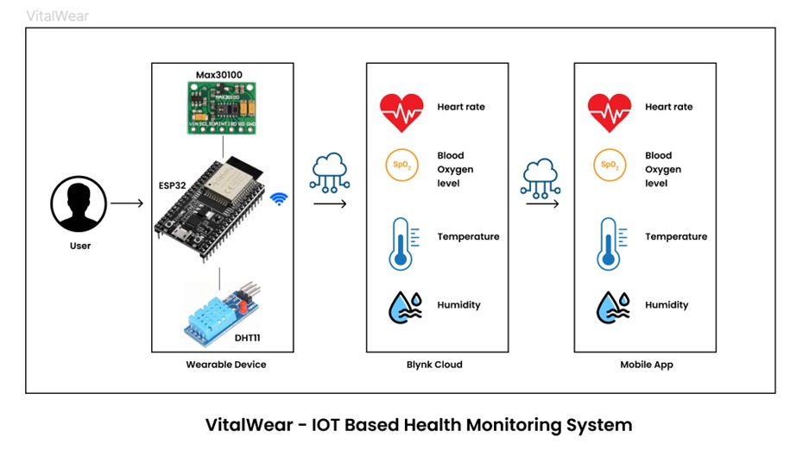

### Figure 2

The VitalWear project's architecture consists of both software and hardware elements that work together to give users a complete health monitoring solution. The central component of the system is the VitalWear wearable, which is fitted with sensors to monitor vital signs such as temperature, humidity, heart rate, and oxygen saturation. These sensors provide data to a microcontroller, which interprets it and sends it to the user's smartphone using a communication module. In terms of software, consumers can view their health data in real time using a mobile application.

The backend server that this application interfaces with is in charge of maintaining user accounts, keeping track of health information, and offering APIs for processing and retrieving data. Additionally, the backend system houses a data processing module that examines sensor data to derive trends and insights regarding the health status and well-being of the user. A system for alerting users to potential health concerns also keeps an eye out for irregularities in the data and sends out messages when it finds them. Bluetooth or Wi-Fi connectivity facilitates integration between components, guaranteeing smooth communication and data sharing. Sensitive health information is protected with the use of security measures including user authentication and encryption. All things considered, VitalWear's architecture aims to give consumers an easy-to-use and dependable way to successfully monitor and manage their health.

**Components:**

**ESP 32:**

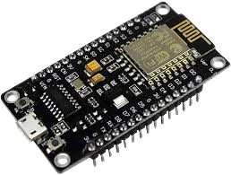

**Figure 3**

Figure 3 The above figure depicts the ESP32 dev kit which is used in VitalWear.

**DHT 11 Sensor:**

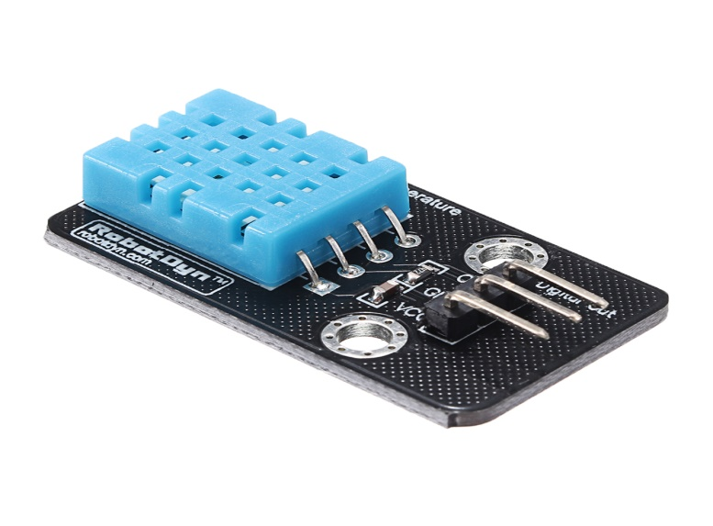

**Figure 4**

Figure 4 dipict the DHT 11 sensor which is used to sense the temperature and humidity.

**MAX 30100:**

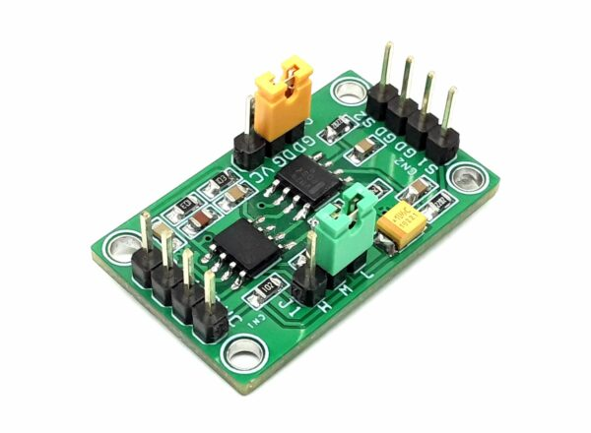

**Figure 5**

Figure 5 depict the MAX 30100 sensor which is used to sense the heart rate and Sp o2 level

**Circuit diagram**

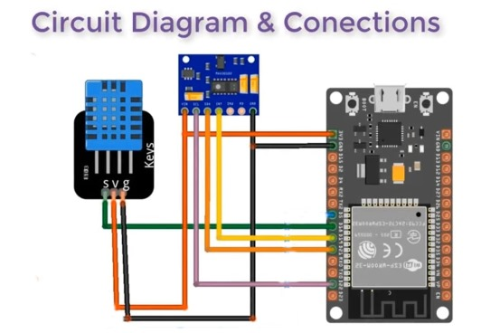

**Figure 6**

Figure 6 depicts how the component of the system which includes MAX 30100, DHT 11 and ESP 32 are connected together using jumper wires.

### VITALWEAR DEVICE:

### C:\Users\God\Downloads\WhatsApp Image 2024-05-20 at 11.08.46 PM.jpeg

**Figure 7**

Figure 7 shows the connections made to the VitalWear to interface with the ESP 32. The connections are provided as specified in the architecture.

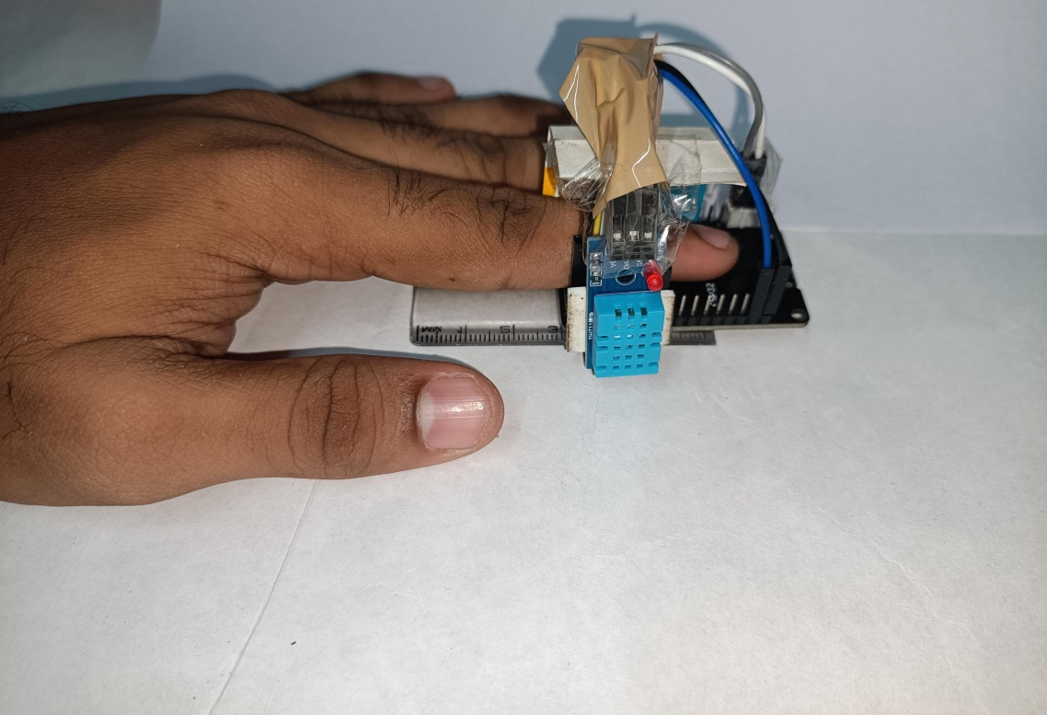

**Figure 8**

Figure 8 depicts the RFID reader which is ready to scan and work as intended in the above sections.

## C:\Users\God\Downloads\WhatsApp Image 2024-05-21 at 10.50.19 AM.jpegOUTPUT

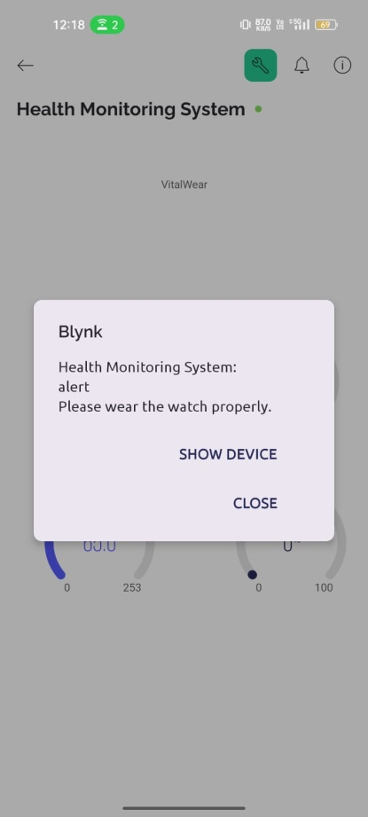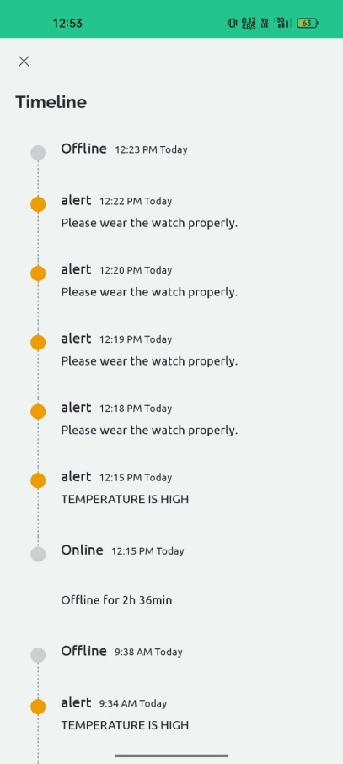

Fig 3 VitalWear Blynk App

The above image shows the values like Blood Oxygen Level , Heart Rate from the MAX30100 and Humdity , Temperature from DHT sensor.

## CHAPTER 4 CONCLUSION AND FUTURE WORK

To sum up, the creation of VitalWear represents a significant progression in the field of personal health management technology. Through the incorporation of real-time vital sign monitoring, such as temperature, humidity, oxygen saturation, and heart rate monitoring, wearable devices provide users with an unforgettable understanding of their health condition. People can easily access and evaluate this data with the help of the accompanying dashboard, which gives them the capacity to make well-informed decisions about their fitness and well-being.

VitalWear has huge potential in the future. Future developments in data analytics and sensor technology could potentially improve the device's functionality even more. Future manifestations may have features like tailored workout routine optimization recommendations, predictive analytics to identify health issues before they develop, and seamless interaction with telemedicine platforms for remote health consultations and monitoring. VitalWear is positioned to take the lead in the ongoing revolution in personal health management as the Internet of Things (IoT) ecosystem grows.

**APPENDIX**

#define BLYNK_TEMPLATE_ID "TMPL3M4fqhU1J"

#define BLYNK_TEMPLATE_NAME "Health Monitoring System"

#include <Wire.h>

#include "MAX30100_PulseOximeter.h"

#include <WiFiClient.h>

#include <BlynkSimpleEsp32.h>

#include "DHT.h"

char auth[] = "SLuqZmzEEQJaEC0YiALtuUUP3MsTYMG2";

char ssid[] = "Siva";

char pass[] = "password";

#define REPORTING_PERIOD_MS 1000

#define DHT_READ_INTERVAL_MS 5000 // Read DHT sensor every 5 seconds

#define DHTPIN 23 // Digital pin connected to the DHT sensor

#define DHTTYPE DHT11 // DHT 11

PulseOximeter pox;

DHT dht(DHTPIN, DHTTYPE);

uint32_t tsLastReportMax30100 = 0;

uint32_t tsLastReportDHT = 0;

float lastTemperature = 0;

float lastHumidity = 0;

int heartRate=0;

int spo2=0;

int lastHeartRate = 0;

int lastSpO2 = 0;

int flag1=0,flag2=0,alert_value=0;

int highflag=0,high_alert=0;

int lowflag=0,low_alert=0;

int spflag=0,sp_alert=0;

void onBeatDetected()

{

Serial.println("Beat!");

}

void setup()

{

Serial.begin(115200);

Blynk.begin(auth, ssid, pass, "blynk.cloud", 80);

Serial.print("Initializing pulse oximeter..");

if (!pox.begin())

{

Serial.println("FAILED");

for (;;)

;

}

else

{

Serial.println("SUCCESS");

}

pox.setOnBeatDetectedCallback(onBeatDetected);

dht.begin();

}

void loop()

{

// Update MAX30100 sensor

pox.update();

bool timeOut=false;

float temp,humi;

// Read MAX30100 sensor data and send to Blynk

if (millis() - tsLastReportMax30100 > REPORTING_PERIOD_MS)

{

heartRate = pox.getHeartRate();

spo2 = pox.getSpO2();

if (heartRate != 0)

{

lastHeartRate = heartRate;

Blynk.virtualWrite(V0, lastHeartRate);

Serial.print("Heart rate: ");

Serial.println(lastHeartRate);

flag1=0;

alert_value=0;

if(heartRate>185)

highflag=1;

else

{

highflag=0;

high_alert=0;

}

if(heartRate>0 && heartRate<50)

lowflag=1;

else

{

lowflag=0;

low_alert=0;

}

}

else

{

lastHeartRate = 0;

Blynk.virtualWrite(V0, lastHeartRate);

Serial.println("Heart rate not available");

flag1=1;

}

if (spo2 != 0)

{

lastSpO2 = spo2;

Blynk.virtualWrite(V1, lastSpO2);

Serial.print("SpO2: ");

Serial.println(lastSpO2);

flag2=0;

alert_value=0;

if(spo2<90)

spflag=1;

else

{

spflag=0;

sp_alert=0;

}

}

else

{

lastSpO2 = 0;

Blynk.virtualWrite(V1, lastSpO2);

Serial.println("SpO2 not available");

flag2=1;

}

if(flag1!=0 || flag2!=0)

{

alert_value++;

flag1=0;

flag2=0;

}

if(highflag!=0)

high_alert++;

if(lowflag!=0)

low_alert++;

tsLastReportMax30100 = millis();

}

// Read DHT sensor data and send to Blynk after a delay

if (millis() - tsLastReportDHT > DHT_READ_INTERVAL_MS)

{

temp = dht.readTemperature();

humi = dht.readHumidity();

if (!isnan(temp))

{

lastTemperature = temp;

Blynk.virtualWrite(V3, lastTemperature);

Serial.print("Temperature: ");

Serial.println(lastTemperature);

}

else

{

lastTemperature = 0;

Blynk.virtualWrite(V3, lastTemperature);

Serial.println("Temperature not available");

}

if (!isnan(humi))

{

lastHumidity = humi;

Blynk.virtualWrite(V2, lastHumidity);

Serial.print("Humidity: ");

Serial.println(lastHumidity);

}

else

{

lastHumidity = 0;

Blynk.virtualWrite(V2, lastHumidity);

Serial.println("Humidity not available");

}

tsLastReportDHT = millis();

}

/*

ALERTS :

*/

bool temptrigger=false;

if(temptrigger==false && temp>=40)

{

temptrigger=true;

Blynk.logEvent("alert","TEMPERATURE IS HIGH");

}

else

{

temptrigger=false;

}

//Serial.println(alert_value);

if(alert_value==60)

{

alert_value=0;

Blynk.logEvent("alert","Please wear the watch properly.");

}

if(high_alert==10)

{

high_alert=0;

heartRate=0;

Blynk.logEvent("alert","Continuous high heart rate is observed. Kindly take safety measures");

}

// if(low_alert>=10)

// {

// low_alert=0;

// heartRate=0;

// Blynk.logEvent("alert","Continuous low heart rate is observed. Kindly take safety measures");

// }

if(sp_alert==10)

{

sp_alert=0;

Blynk.logEvent("alert","Low blood oxygen level is detected.");

}

Blynk.run();

**REFERENCE**

[1] T. M. Kadarina and R. Priambodo, "Preliminary design of Internet of Things (IoT) application for supporting mother and child health program in Indonesia," 2017 International Conference on Broadband Communication, Wireless Sensors and Powering (BCWSP), Jakarta, Indonesia, 2017, pp. 1-6, doi: 10.1109/BCWSP.2017.8272576.

[2] I. Buleje et al., "A Versatile Data Fabric for Advanced IoT-Based Remote Health Monitoring," 2023 IEEE International Conference on Digital Health (ICDH), Chicago, IL, USA, 2023, pp. 88-90, doi: 10.1109/ICDH60066.2023.00021.

[3] A. V. Jerald and S. Albert Rabara, "Secured Architecture for Internet of Things (IoT) Based Smart Healthcare," 2020 International Conference on Inventive Computation Technologies (ICICT), Coimbatore, India, 2020, pp. 828-833, doi: 10.1109/ICICT48043.2020.9112586.

[4] V. B. Shalini, "Smart Health Care Monitoring System based on Internet of Things (IOT)," 2021 International Conference on Artificial Intelligence and Smart Systems (ICAIS), Coimbatore, India, 2021, pp. 1449-1453, doi: 10.1109/ICAIS50930.2021.9396019.

[5] L. Gohlke, F. Dreyer, M. P. Álvarez and J. Anders, "An IoT based low-cost heart rate measurement system employing PPG sensors," 2020 IEEE SENSORS, Rotterdam, Netherlands, 2020, pp. 1-4, doi: 10.1109/SENSORS47125.2020.9278844.

[6] N. E. J. Asha, Ehtesum-Ul-Islam and R. Khan, "Low-Cost Heart Rate Sensor and Mental Stress Detection Using Machine Learning," 2021 5th International Conference on Trends in Electronics and Informatics (ICOEI), Tirunelveli, India, 2021, pp. 1369-1374, doi: 10.1109/ICOEI51242.2021.9452873.

[7] R. R. Rajanna, S. Natarajan and P. R. Vittal, "An IoT Wi-Fi Connected Sensor For Real Time Heart Rate Variability Monitoring," 2018 3rd International Conference on Circuits, Control, Communication and Computing (I4C), Bangalore, India, 2018, pp. 1-4, doi: 10.1109/CIMCA.2018.8739323.

1. Biswal, Anil Kumar, et al. "IoT-based smart alert system for drowsy driver detection." Wireless communications and mobile computing 2021 (2021): 1-13.
2. Chandiwala, Janki, and Shrushti Agarwal. "Driver’s real-time drowsiness detection using adaptable eye aspect ratio and smart alarm system." 2021 7th International Conference on Advanced Computing and Communication Systems (ICACCS). Vol. 1. IEEE, 2021.
3. Albadawi, Yaman, Maen Takruri, and Mohammed Awad. "A review of recent developments in driver drowsiness detection systems." *Sensors* 22.5 (2022): 2069